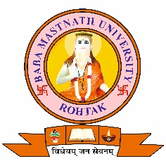
BABA MASTNATH UNIVERSITY
Asthal Bohar Rohtak

ONE DAY EXTENSION LECTURE
On
INDIAN KNOWLEDGE SYSTEM
12th May 2025
Speaker : Prof Jagdish Bhardwaj(Dept of Sanskrit, BMU, Rohtak)
Organized by
Cultural Club, BMU, Rohtak
In Association with
Internal Quality Assurance Cell (IQAC)

